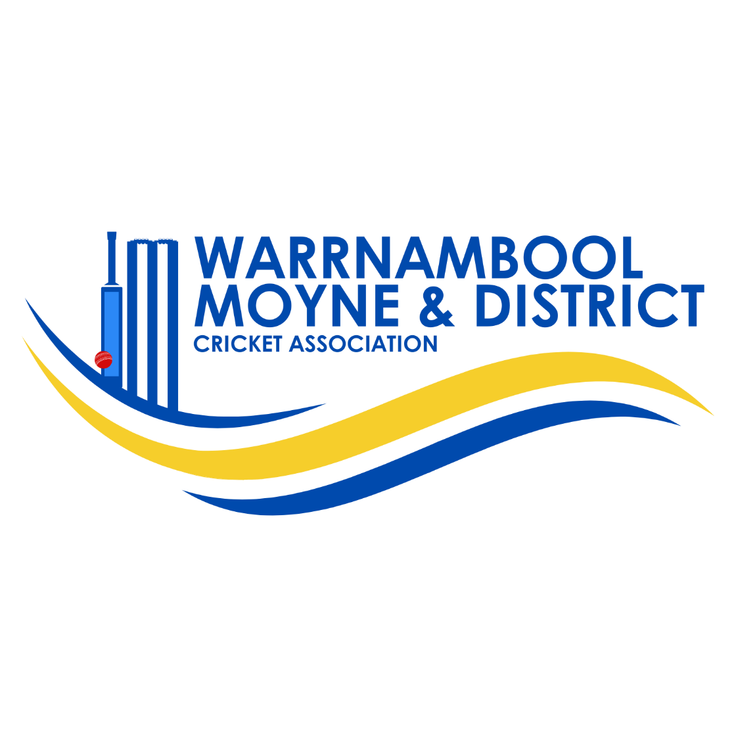Women’s
Cricket
Competition

PLAYING CONDITIONS
SEASON 2024/25

Last Updated 19 October 24
WMDCA WOMEN’S CRICKET COMPETITION PLAYING CONDITIONS.
General Conditions
Matches will be played on Sunday afternoons commencing at a time and venue as determined by the Match Committee and the approved playing schedule. Matches will be played on synthetic hard centre wickets or in some cases turf wickets when that surface is available. Twilight turf matches under lights will be included.
All players playing in the WMDCA women’s competition are required to be first registered online on the Competition Management Platform as a Senior player to a primary club. Once registered and assigned to their primary club they will require a transfer to play for any other WMDCA club or elsewhere.
14 years is the minimum age permitted for a player to play in the Women’s cricket competition.
Hours of Play (Sunday Play)
1pm to 2.30pm - 1st session.
2.30pm to 2.45pm Innings break.
2.45 to 4.15pm - 2nd Session.
Dates of Play
Sunday matches are the scheduled day of play for Women’s Cricket.
It is also planned that a Sunday turf round will be included in the season’s fixture when opportunity arises.
Match Playing Format
The Women’s Cricket playing conditions comprise of short form matches based on the standard T20 rules with some modifications. Fielding restrictions for these games are referred to under the heading Fielding overleaf.
The fielding restrictions referred to here only relate to the standard T20 rules which includes only 2 allowed outside the circle for the first 6 overs, and 5 allowed for the remaining overs.
Each team will bat for 25 overs unless dismissed earlier. The second batting team is entitled to receive their allocated 25 overs if not dismissed. A minimum of 5 overs each team constitutes a match.
Ground size will be a maximum of 45 metres with the boundary marked by cones.
Batting
Players will compulsory retire at 60 runs and cannot return to bat. The compulsory retired player is recorded as a fall of wicket
If a team has less than 11 players, players can return to bat until the innings is complete (fall of 10th wicket).
Players return to bat in order from lowest to highest score.
Bowling
Five overs maximum per bowler, with one three over spell permitted. All players should bowl at least one over.
A maximum of 8 balls per over to be bowled irrespective of no balls or wides bowled. However the last over of any innings must have 6 legal deliveries.
The front foot no ball and a waist high full toss no ball rule applies and entitles the batter to a free hit.
Double bouncers are deemed a no ball.
Lenient wides interpretation ruling to apply.
LBW only applies when struck on the pads directly in front of the wicket at the crease.
5 overs to be bowled at a time from each end before swapping ends.
Fielding
Fielding restrictions will apply with 2 compulsory players on the boundary for the first 10 overs and then a minimum of 2 and a maximum of 4 players out on the boundary for the remainder of the match.
Umpires
Official umpires will be appointed to the matches. Participating clubs will be invoiced by the WCUA. Batting sides will be required to supply a square leg umpire.
Wet Weather
Wet weather playing conditions will be as documented in the WMDCA Senior T20 rules.
Equipment
A Kit of Stumps and bails to be provided by the home club.
A 142gm Kookaburra red leather ball will be utilised in daylight matches.
A white 142gm Kookaburra ball will be used in twilight and night matches.
Match day requirements are as follows.
Batters must wear approved helmets
Batting Pads and Gloves to be worn
An approved helmet, gloves and pads must be worn by the Wicketkeeper at all times.
Playing Uniform
Team players are to wear approved club coloured playing tops in match play. Cricket Whites or other coloured playing tops are permissible, as long as the uniform is consistent across the team. Long pants are to be worn.
Scoring and Match Results
A scorebook will be supplied by the WMDCA at the commencement of the competition for each team, iPads can be utilised but in this case there must also one scorebook in use. All players batting and bowling/wickets/catches/ runs/extras are to be recorded as per normal scoring practices.
Match results are to be entered on the Competition Management Platform within 48 hours of the match being played. It is important that players are registered on the system for this to occur before the individuals first day of play.
Results of matches will be published in the Standard newspaper.
Player of the season award
A senior women’s division player of the season award will be voted upon this season. The votes comprise of 4,3,2 and 1, issued by the umpire. If no umpire, votes to be awarded by each captain in collaboration. Other awards including best batting, best bowling and a fielding award will be also awarded at the end of the season.
To be eligible for this award, a player must have made 125 runs for batting, 15 overs bowled to be eligible for the bowling.
Finals Play
To qualify for finals matches, a player must have played at least three matches in a women’s team in this competition.
Sunday finals matches are extended to 30 overs per side. Batting retirements will remain at 60 runs. Bowlers will be permitted to bowl a maximum of 6 overs in 3 over spells.
Match Points;
Win – 6 points Loss – 0 points Tie - 3 points Drawn Match - 3 points.
Where an uneven number of Byes occur, 6 points will be allocated for a Bye.
Clubs coaches/managers.
All club coaches must possess, as a minimum, a current accreditation level 1 (community coach), or gain such a qualification as soon as practical on their appointment. Coaches/managers must possess a current working with children certificate
Contacts for Women’s Cricket;
Ingrid Bellman – Director of girls cricket, Mobile No. 0431 231 651
Hannah Meates – Director of womens cricket, Mobile No. 0475 949 809
Gordon McLeod - WMDCA Chairperson, Mobile No. 0408 990 590.

